# ***The Water-Treatment Process***

Before people can safely use water, it must be found, treated, and transported to households. The treatment piece of this process is called the **water-treatment process.** The water treatment process involves four steps, in this order: coagulation, sedimentation, filtration, and disinfection, sludge drying, fluoridation and pH Correction.

#### Coagulation / Flocculation

During coagulation, liquid aluminum sulfate (alum) and/or polymer is added to untreated (raw) water. When mixed with the water, this causes the tiny particles of dirt in the water to stick together or coagulate. Next, groups of dirt particles stick together to form larger, heavier particles called flocs which are easier to remove by settling or filtration.

#### Sedimentation

As the water and the floc particles progress through the treatment process, they move into sedimentation basins where the water moves slowly, causing the heavy floc particles to settle to the bottom. Floc which collects on the bottom of the basin is called sludge, and is piped to drying lagoons. In Direct Filtration, the sedimentation step is not included, and the floc is removed by filtration only.

#### Filtration

Water flows through a filter designed to remove particles in the water. The filters are made of layers of sand and gravel, and in some cases, crushed anthracite. Filtration collects the suspended impurities in water and enhances the effectiveness of disinfection. The filters are routinely cleaned by backwashing.

#### Disinfection

Water is disinfected before it enters the distribution system to ensure that any disease-causing bacteria, viruses, and parasites are destroyed. Chlorine is used because it is a very effective disinfectant, and residual concentrations can be maintained to guard against possible biological contamination in the water distribution system.

#### Sludge Drying

Solids that are collected and settled out of the water by sedimentation and filtration are removed to drying lagoons.

Fluoridation

Water fluoridation is the treatment of community water supplies for the purpose of adjusting the concentration of the free fluoride ion to the optimum level sufficient to reduce dental caries.

pH Correction

Lime is added to the filtered water to adjust the pH and stabilize the naturally soft water in order to minimize corrosion in the distribution system, and within customers’ plumbing.

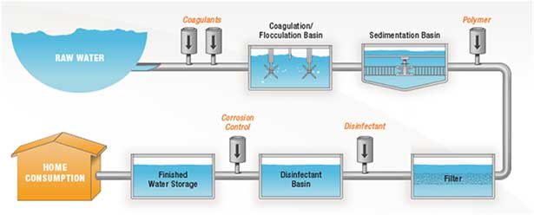

# ***Problem/Solutions with The Water-Treatment Process***

Technologies for potable water and other uses are well developed and a number of private companies provide patented technological solutions for treatment of specific contaminants. Source water quality through the seasons, scale and environmental impact can dictate capital costs and operating costs.

**Energy Consumption**

Drinking water and wastewater treatment plants are typically the largest energy consumers, having a total of 30-40% of the cities' energy consumption. High amount of energy is needed to mix the large volume of water to allow sedimentations to flocculate together. Pumping and Aeration equipment technologies aim to reduce this amount of energy. The effectiveness of such technologies is still under discussion.

A notable example that combines both wastewater treatment and drinking water treatment is NEWater in Singapore. NEWater is a technology practiced in Singapore that converts wastewater to potable water. More specifically, it is treated wastewater(sewage) that has been purified using dual-membrane (via microfiltration and reverse osmosis) and ultraviolet technologies, in addition to conventional water treatment processes.

**Society and Culture**

Waterborne diseases are estimated to have caused 1.8 million deaths each year. These deaths are attributable to inadequate public sanitation system and lack of proper sewage system. Appropriate technology options in water treatment are developed to address both community-scale and household-scale point-of-use (POU) designs. Such designs may employ solar water disinfection methods, using solar irradiation to inactivate harmful waterborne microorganisms directly, mainly by the UV-A component of the solar spectrum, or indirectly through the presence of an oxide photo catalyst.

Newer military style Reverse Osmosis Water Purification Units (ROWPU) are portable, self-contained water treatment plants are becoming more available for public use.

# Filtration

## Slow Sand Filtration

Filtration is one of the many steps involved in water treatment process. Slow sand filters are developed to effectively remove turbidity and pathogenic organisms through various biological, physical and chemical processes in a single treatment step. Slow sand filtration systems are characterized by a high reliability and rather low lifecycle costs. Moreover, neither construction nor operation and maintenance require more than basic skills. Hence, slow sand filtration is a promising filtration method for small to medium-sized, rural communities with a fairly good quality of the initial surface water source. slow sand filtration provides a simple but highly effective and considerably cheap tool that can contribute to a sustainable water management system.

Membrane Filtration

Membranes are thin and porous sheets of material able to separate contaminants from water when a driving force is applied. Once considered a viable technology only for desalination, membrane processes are increasingly employed in both drinking water and wastewater treatment for removal of bacteria and other microorganisms. As advancements are made in membrane production and module design, capital and operating costs continue to decline.